Twerton and Whiteway Community Network
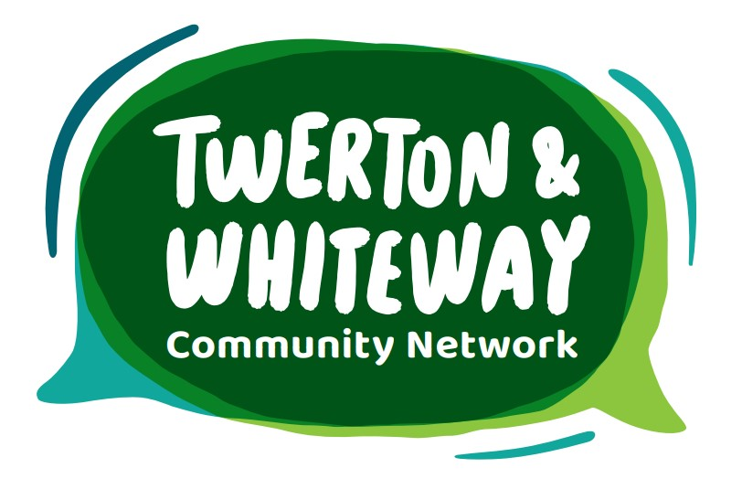
Dragons’ Den Grants Application Form

Applicant name: _______________________________________

Organisation/group name: _______________________________________ (if applicable)

Type of applicant: Individual ☐ Group ☐ Organisation ☐

If you’re applying as a group/organisation, please email your latest accounts or financial statements to hello@twertonandwhiteway.org (maximum annual income level for these grants is £50,000)

Address: _____________________________________________________________

Postcode: __________________

Email: _____________________________________________________________

Phone number: __________________

Project Name: __________________

What is your project?
(What does your project do or plan to do? How does it meet the grant criteria below? How will it benefit the Twerton and Whiteway community? How many people will benefit? Will anything continue beyond the grant?)

Which criteria does your project meet? (please tick at least one box)

☐ Celebrating Twerton and Whiteway
☐ Making Twerton and Whiteway an active place
☐ Making Twerton and Whiteway a cleaner place
☐ Making Twerton and Whiteway a friendlier place
☐ Making Twerton and Whiteway a greener place
☐ Making Twerton and Whiteway a healthier place
☐ Making Twerton and Whiteway a more accessible place
☐ Making Twerton and Whiteway a safer place

How much money will your project cost? £
We have ten grants of up to £300 available for this first Dragons’ Den event.

How much money are you applying for? £

Do you have match funding? Yes / No / Not needed

If so, how much? £

How will this money be spent? (please give a breakdown of estimated costs)

- Please confirm that you would be available to attend Dragons’ Den event at the Centurion on 7th June from 4.30-7pm to 'pitch' your idea to the local community

- Please confirm that you have read the guidance (www.twertonandwhiteway.org/dragons-den-small-grants-scheme) and understand the information about how grants will be paid and the need to provide feedback on your project - this could be as a video, series of photos, or a short written report

Please email your completed application to hello@twertonandwhiteway.org
or deliver/post to the Twerton and Whiteway Community Network at Bath City Farm
(Kelston View, Bath, BA2 1NW)

